Name: ____________________________________________________ Class;________
2024 TERM 1 MZIMBA NORTH DISTRICT EXAMINATIONS

AGRICULTURE FORM 2

(100 Marks)

Tuesday, 16 December
Time allowed: _2 hours
7:30 – 9:30 am

INSTRUCTIONS:

- Write your official name and class on top of every each and every page.
- The paper contain two sections A, B and C, on 12 printed pages. Please check.
- In section A, there are twenty multiple choice questions. While in section B, there are ten short answer questions and in three essay questions in section C.
- Answer all the questions in the spaces provided.
- Marks are indicated against each question for sections B and C

©MZN-T1-2

SECTION A (20 marks)
Answer all questions in this section by encircling the letter corresponding to the correct answer. Each question carries 1 mark.

- Which of the following marketing function changes the state of product into more suitable and acceptable form?
  - Advertising
  - Processing
  - Storage
  - Grading
- Which of the following is the effect of climate change on land?
  - weed infestation
  - siltation
  - soil degradation
  - disease prevalence
- Which of the following is the importance of agricultural marketing?
  - promotes unemployment
  - provides government revenue
  - provide recreational services
  - promotes food insecurity
- Farmers can deal with risks and uncertainties through
A. Diversification of enterprises
B. Mono cropping
C. Adding value to the product
D. Sell crops to the ADMARC
- Which of the following feeds should be given to layers between 6 and 20 weeks?
    - Growers mash
    - Layers mash
    - Finishers mash
    - Chick mash
Figure 1 shows a vegetable pest. Use it to answer question 6 and 7.
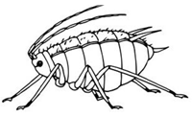
Figure 1
- Name the pest.
- Thrip
- Aphid
- Caterpillar
- Grasshopper

- Which of the following methods can best control the pest?
    - chemical
    - cultural
    - physical
    - biological
- The following are the importance of soil except
    - increases the rate of evapotranspiration
    - provides nutrients to the plants
    - It provides soil water to plants.
    - It anchors the plants.
- Which of the following are natural causes of climate change?
1. Solar radiation
  - fossil fuel burning
  - production of aerosols
  - volcanic activities
    - 1 and 2
    - 1 and 4
    - 2 and 3
    - 3 and 4

- Which of the following is not a straight fertiliser?
    - Urea
    - CAN
    - Sulphate of ammonia
    - NPK

- In the soil profile, which soil layer is known as zone of accumulation?
    - Sub soil
    - Weathered rock
    - Bed rock
    - Top soil
- Which of the following are biological weathering agents?
    - Plants and animals
    - Water and wind
    - Wind and temperature
    - Water and carbonic acid

- Which of the following technologies can improve livestock production?
  - use of herbicides
  - use of commercial feeds
  - use of large animal houses
  - use of exotic breeds
  - 1 and 3
  - 2 and 3
  - 1 and 4
  - 2 and 4

- Which of the following activities would maintain soil fertility?
      - minimum tillage
      - continuous cropping
      - untimely weeding
      - cultivating along river banks
- Which of the following activities is a physical method of conserving water?
      - making terraces
      - making fire breaks
      - crop rotation
      - rotational grazing

The table below shows demand and supply of tomatoes in relation to price.
Use it to answer Questions 16 and 17.
Price(Mk/kg) | Demand  (kg) | Supply  (kg)
40 | 330 | 150
50 | 300 | 210
60 | 240 | 240
70 | 200 | 330
The market price is
      - 40 Mk/kg
      - 50 Mk/kg
      - 60 Mk/kg
      - 70 Mk/kg
- At a price of 70 Mk/kg supply is higher than demand, what would you advise a tomato seller?
    - increase supply
    - reduce supply
    - reduce price
    - increase price
Figure 2 shows an agricultural technology. Use it to answer Questions 18 and 19.
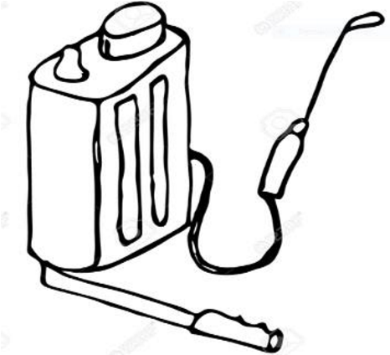
Figure 2
- Name the technology
    - water pump
    - sprayer
    - brooder
    - plough
- The technology is used in
    - livestock breeding
    - livestock feeding
    - crop protection
    - crop processing

- Which of the following can deal with risks in farm business management?
  - insurance
  - government policy
  - pest and diseases
  - political instability

Section B (50 marks)
Answer all questions in this section in the spaces provided.
- a. State any two effects of rapid population growth on water resources.
_____________________________________________________________________
_____________________________________________________________(2 marks)
  - Give any two roles of agro-based industries in supporting the growing population.
_____________________________________________________________________
_____________________________________________________________ (2 marks)
Table 1 below shows a type of experimental design. Use it to answer questions that follow
 | BLOCK 1 | BLOCK 2 | BLOCK 3
PLOT 1 | PANAR 67 | KANYANI | DK 8033
PLOT 2 | KANYANI | LOCAL MAIZE | PANNAR 67
PLOT 3 | DK 8033 | PANAR 67 | LOCAL MAIZE
PLOT 4 | LOCAL MAIZE | DK 8033 | KANYANI

- a. Identify the type of experimental design in the table above
_____________________________________________________________ (1 mark)
  - What is the aim of the experiment
_____________________________________________________________________
_____________________________________________________________ (1 mark)
c. State the control treatment
_____________________________________________________________ (1 mark)
d. Give any two factors to consider when laying out agricultural experiments.
__________________________________________________________________________________________________________________________________ (2 marks)

- a. State any two problems associated with capital as a factor of production
_____________________________________________________________________
___________________________________________________________ (2 marks)
  - Explain any two ways of controlling predators in chicken production.
_____________________________________________________________________ _____________________________________________________________________ _____________________________________________________________________
____________________________________________________________(4 marks)
- a. Figure 3 shows a method of irrigation system
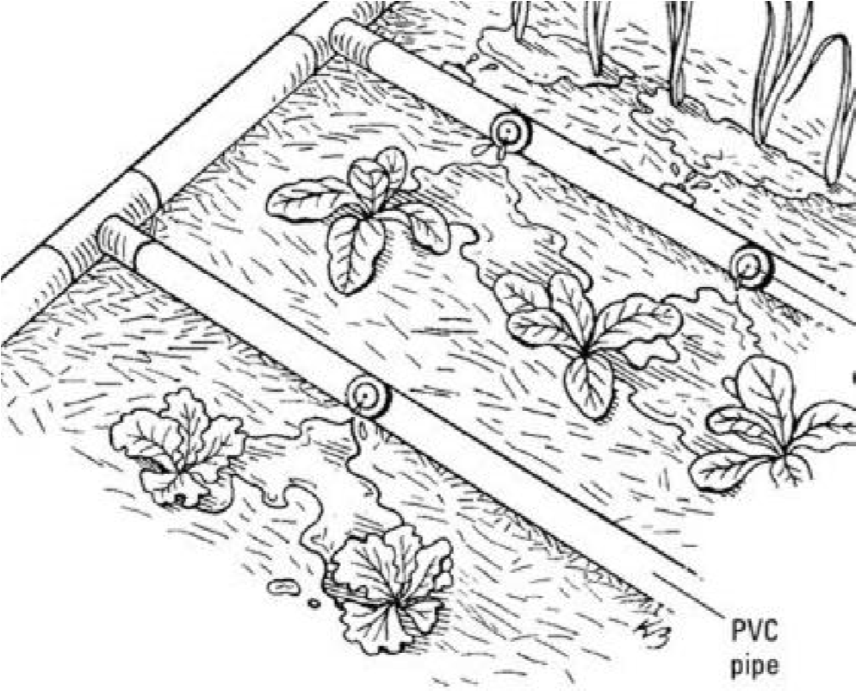
Figure 3
Name the irrigation system
________________________________________________________ (1 mark)
- State any two ways of maintaining the irrigation system
__________________________________________________________________
______________________________________________________________(2 marks)
- Give any two ways in which vegetation can be conserved
_____________________________________________________________________
___________________________________________________________(2 marks)
- a. Give any two types of capital
_____________________________________________________________________ ____________________________________________________________(2 marks)
b. Explain any two effects of climate change on people’s livelihood
_____________________________________________________________________
_____________________________________________________________________
_____________________________________________________________________
____________________________________________________________ (4 marks)
- a. Explain the importance of the following activities in vegetable production.
- ‘hardening off’
__________________________________________________________________
_________________________________________________________(2 marks)
- ‘thinning’
__________________________________________________________________
_________________________________________________________(2 marks)
b. Explain any one factor to consider when selecting an irrigation system.
_____________________________________________________________________
____________________________________________________________(2 marks)
27. A farmer observed the following in chicken: loss of body weight, gasping, cough and sneezing, difficulties in breathing.
- Name the disease that attacked the chicken
___________________________________________________________ (1 mark)
- Name the organism that causes this disease
____________________________________________________________ (1 mark)

- Mention any two ways of controlling the disease
_____________________________________________________________________
____________________________________________________________(2 marks)
28. a. Give any one source of essential plant nutrients.
_____________________________________________________________________
____________________________________________________________(1 mark)
b. Explain any one advantage of organic fertiliser.
_____________________________________________________________________
____________________________________________________________(2 marks)
29. a. A farmer applied 150 kilograms of 23:21:0 +4S fertilizer in his garden, how many kilograms of Nitrogen were applied on this farm?

(2 marks)
b. Describe any one difference between fertile and infertile soil
_____________________________________________________________________
____________________________________________________________(2 marks)
c . Name the group of vegetables to which each of the following belong
- carrot___________________________________________________________
(1 mark)
- pepper _______________________________________________________________
(1 mark)
- a. Bakhresa Grain and Milling (Malawi) Limited is an agro-based industry. Mention any two raw materials used by the industry?
____________________________________________________________________
______________________________________________________________(2 marks)
b Mention any one physical marketing function done by the milling company _________________________________________________________(1 mark)
c. Give any two roles of living organism in the soil.
_____________________________________________________________________
_____________________________________________________________(2 marks)

SECTION C (30 marks
Answer all the questions in essay form in the spaces provided.
- Explain five effects of climate change on cattle farming.
______________________________________________________________________________________________________________________________________________________________________________________________________________________________________________________________________________________________________________________________________________________________________________________________________________________________________________________________________________________________________________________________________________________________________________________________________________________________________________________________________________________________________________________________________________________________________________________________________________________________________________________________________________________________________________________________________________________________________________________________________________________________________________________________________________________________________________________________________________________________________________________________________________________________________________________________________________________________________________________________________________________________________________________________________________________________________________________________________________________________________________________________________________________________________________________________________________________________________________________________________________________________________ (10 marks)

32. Describe any five ways in which essential plant nutrients are depleted from the soil
____________________________________________________________________________________________________________________________________________________________________________________________________________________________________________________________________________________________________________________________________________________________________________________________________________________________________________________________________________________________________________________________________________________________________________________________________________________________________________________________________________________________________________________________________________________________________________________________________________________________________________________________________________________________________________________________________________________________________________________________________________________________________________________________________________________________________________________________________________________________________________________________________________________________________________________________________________________________________________________________________________________________________________________________________________________________________________________________________________________________________________________________________________________________________________________________________________________________________________________________________________________________________________________________________________________________________________________________________________________________________________________________________________________________________________________________________________________________________________________________________________________ (10 marks)
33. Explain five importance of agricultural marketing to the growing population of Malawi.
__________________________________________________________________________________________________________________________________________________________________________________________________________________________________________________________________________________________________________________________________________________________________________________________________________________________________________________________________________________________________________________________________________________________________________________________________________________________________________________________________________________________________________________________________________________________________________________________________________________________________________________________________________________________________________________________________________________________________________________________________________________________________________________________________________________________________________________________________________________________________________________________________________________________________________________________________________________________________________________________________________________________________________________________________________________________________________________________________________________________________________________________________________________________________________________________________________________________________________________________________________________________________________________________________________________________________________________________________________________________________________________________________________________________________________________________________________________________________________________________________________________________________________________________________________________________________________________________________________________________________________ (10 marks)

END OF QUESTION PAPER

